Biography

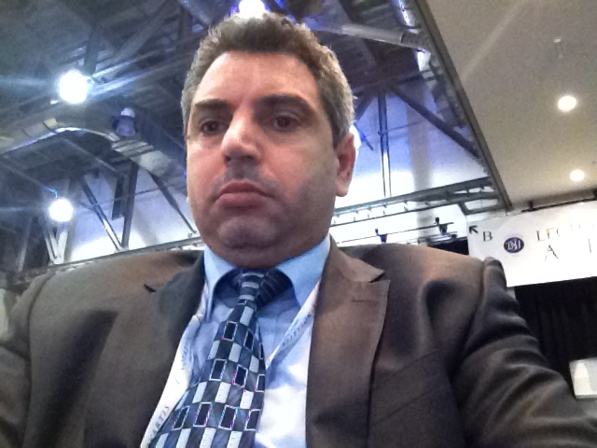
Mohamed A. S. Attia is the Assistant Professor of clinical pathology (molecular haematology) at Faculty of medicine, Tanta University, Egypt and the Director of the flow cytometry laboratory working on leukemia & lymphoma diagnosis and follow up. He is the director of flow cytometry laboratory development and accreditation project (July 2013). He obtained his PhD in 2005 from St George’s University of London, UK. His PhD research was about the development of DNA microarray method to study the effect of inflammatory cytokines on the gene expression profile CD34⁺ haemopoietic stem cells. He has published more than 20 articles in peer-reviewed journals and attended more than 20 national and international workshops and conferences in molecular haematology and flow cytometry. He is a member of European Haematology association and Egyptian society of Haematology. Dr Attia’s research focuses on understanding the behavior of circulating tumor cells and MRD in leukemia and lymphoma. Additionally his research has been focusing on therapeutic applications of stem cell.

