**Biography**

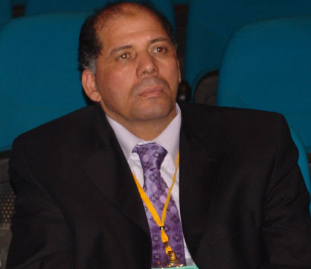Mohamed L. Salem is the Professor of Immunology at Tanta University, Egypt and the Director of the Grant, Innovation & Technology Transfer Center, and Director of Center of Excellence in Cancer research, Tanta University. He obtained his PhD in 1995 from Tanta University, Egypt and Kyushu University, Japan. From 1997 -2001, he was a Postdoctoral Fellow at Kyushu University, Japan and from 2002-2010 as an Assistant Professor at Medical University of South Carolina, USA. Dr Salem was awarded the State Incentive Award in 2004 and the State Excellent Award in 2010 in Basic Sciences from the Academy of Scientific Research and Technology, Egypt. He has published more than 75 articles in peer-reviewed journals and attended more than 70 national and international workshops and conferences in Immunology. He is a member of several editorial boards of peer-reviewed journals as well as ad hoc reviewer for more than 80 journals. His research projects have been funded by National Institute of Health, USA, Science and Technology Development Fund (STDF), Egypt, National Academy of Sciences, USA and Tanta University, Egypt, as well as by industry. He is a member of the national Committee for Promotion of Professorship, Egypt. He has delivered talks in cancer immunotherapy in Egypt, UAE, Jordan, Saudi Arabia, USA, Canada, and Canada. Dr Salem’s research focuses on understanding the cellular and molecular mechanisms underlying how cancer and HCV escape from host immunity, in particular the rules of immunoregulatory cells including lymphoid and myeloid lineages. Additionally his research has been focusing on developing effective anticancer immunotherapies strategies, in particular the use of adoptive cell therapy.